INTERNATIONAL SCIENTIFIC COLLOQUIUM “ETHICS AND PROFESSIONAL DEONTOLOGY IN RESEARCH AND PRACTICE IN THE SOCIO-BEHAVIORAL SCIENCES FIELD”
CHIȘINĂU, ULIM, May 7-8, 2020
Aula Magnifica, ULIM, 52, Vl. Parcalab street, Chisinau, Republic of Moldova
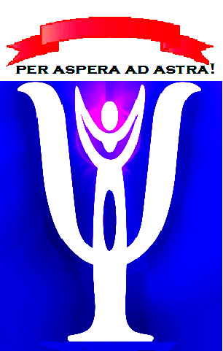

Faculty of Social and Educational Sciences, ULIM ,
in partnership with
Doctoral School of Economic, Social and Informational Technologies Sciences, ULIM,
Lumen Research Center in Social and Humanistic Sciences
Faculty of Psychology, Educational Sciences and Social Work “Petre Andrei”, Iași, Romania,
Institute of Psychology, Russian Academy of Sciences, Moscow, Russia,
Faculty of Social and Educational Sciences, Psychology and Arts, State University “Alecu Russo”, Balti,
Psycho-Socio-Pedagogical Center of Chisinau

PARTICIPATION FORM
(should be sent before April 18, 2020 on the following e-mail: psw.department.ulim@gmail.com)

First Name and Surname: ____________________________________________________
Institution of affiliation: _____________________________________________________
The position and scientific title: _______________________________________________
Contact info: tel. _______________________ E-mail: ___________________________
Type of participation (mark with X the appropriate option):
( ) audient;
( ) participant with communication/paper in one of the conference section (mark the appropriate):
( ) Ethical standards in clinical psychology, psychological counseling and psychotherapy
( ) Ethical standards in psycho-diagnostic activity
( ) Ethical standards in the activity of educational psychologists
( ) Ethical standards in the activity of social, legal, military psychologists
( ) Ethical standards in social work
( ) Ethical standards in scientific research
( ) Session of posters
If you prefer to participate with a paper, please mention the title (in Romanian/Russian and English):
___________________________________________________________________________
______________________________________________________________________________________________________________________________________________________

If there are more authors, please mention for each of them the first name, last name; institution affiliation; the position and scientific title:
1.
2.

Please add the abstract in Romanian/Russian (max. 350 words / 2500 signs, Times New Roman, 12 pt, space 1,0):
Add the keywords in Romanian/Russian:

Please add the abstract English (max. 350 words / 2500 signs, Times New Roman, 12 pt, space 1,0):
Add the keywords in English:

Regarding the poster presentation we will inform you additionally.

The participation fees:

- As audient with participation in workshops (certificate of participation) | 150 MDL
- Participation with communication and publishing the abstract in “Working papers” | 200 MDL
- Purchasing the volume with works presented in plenary session of the colloquium by invited researchers well-known in the given domain | 300 MDL
The fees are paid on the day of registration by the conference guests from outside of the Chisinau mun., or till 01.05.2020 (after the admission of the participation form) - by the participants from Chisinau.
By sending the abstract and participation form you agree with the following Declaration according to which you give us the right to publish and to include the presented material (s)for conference in international databases.

DECLARATION ON OWN RESPONSABILITY (AFFIDAVIT) REGARDING THE INTELLECTUAL PROPERTY OF THE COPYRIGHT, INDUSTRIAL PROPERTY AND PUBLICATION IN OPEN ACCESS

I, declare on my own responsibility and according to previsions of the art. 96 of the Contravention Code of the Republic of Moldova (nr. 218, 24.10.2008), art. 11 and 14 of the Law on copyright and related rights (nr. 139, 02.07.2010), that the paper announced in the given Registration form, which has to be published in the International Scientific Colloquium “Ethics and professional deontology in research and practice in the socio-behavioral sciences field”, May 7-8, 2020, Working papers, belonging to the Free International University of Moldova, represents a personal, authentic, genuine contribution.

No part of the given work, except the citations, graphs, tables or text excerpts adjusted by explicit notes to bibliographical references, is taken from another work. Elaborating the work, I consulted documents mentioned in endnotes and bibliographical references, presented at the end of the work according to the legislation of the Republic of Moldova and international conventions on copyright. The work belongs to me and does not represent plagiarism.

I accept to delegate the exclusive copyright to Free International University of the Republic of Moldova, to publish the work in Open Access and I undertake to not transmit the given text to another entity/organization to publish or spread it.

I accept the integration/inclusion of the given work into International Databases, where the institute publications are registered.

Date:

